A physiologically-based kinetic (PBK) model for work-related diisocyanate exposure: relevance for the design and reporting of biomonitoring studies and opportunities for further improvement
Scholten, B.^{1*}, Westerhout, J.¹, Pronk, A.¹, Stierum, R.¹, Vlaanderen, J.², Vermeulen, R.², Jones, K.³, Santonen, T.⁴, Portengen, L².
¹Risk Assessment for Products in Development, TNO Quality of Life, The Netherlands
² Institute for Risk Assessment Sciences, Utrecht University, The Netherlands.
³ Health and Safety Executive (HSE), Harpur Hill, Buxton, UK
⁴ Finnish Institute of Occupational Health (FIOH), Finland
*To whom correspondence should be addressed. Email: bernice.scholten@tno.nl

Appendix A – Description of compartments

General circulation
The arterial and venous blood compartments are subdivided into unbound, albumin and macromolecule compartments. Because of the high reactivity of diisocyanates, we assume that no unbound diisocyanates will be available for renal clearance. In addition, we assumed that only the diisocyanates bound to other macromolecules can be excreted into urine, so that albumin-bound diisocyanates only become available for excretion after conjugation (elimination).
The amount of diisocyanates in the different arterial blood sub-compartments is described by the following differential equations (Eq. 1 – 3):
$dt\left(A_{art[ub]}\right)=Q_{c}*{(C}_{vas[ub]}-C_{art\left[ub\right]})-k_{alb}*A_{art\left[ub\right]}-k_{mcr}*A_{art[ub]}$ (Eq. 1)
$dt\left(A_{art[alb]}\right)=Q_{c}*\left(C_{vas[alb]}-C_{art[alb]}\right)+k_{alb}*A_{art\left[ub\right]}-k_{elim}*A_{art[alb]}$ (Eq. 2)
$dt\left(A_{art[mcr]}\right)=Q_{c}*{(C}_{vas[mcr]}-C_{art[mcr]})+k_{mcr}*A_{art\left[ub\right]}+k_{elim}*A_{art[alb]}$ (Eq. 3)
The amount of diisocyanates in the different venous blood sub-compartments is described by the following differential equations (Eq. 4 – 6):
$dt\left(A_{ven[ub]}\right)=Q_{skn}*C_{skn\left[ub\right]}+(Q_{c}-Q_{skn})*C_{rem\left[ub\right]}-Q_{c}*C_{ven\left[ub\right]}-k_{alb}*A_{ven\left[ub\right]}-k_{mcr}*A_{ven[ub]}$ (Eq.4)
$dt\left(A_{ven[alb]}\right)=Q_{c}*{(C}_{art[alb]}-C_{ven[alb]})+k_{alb}*A_{ven\left[ub\right]}-k_{elim}*A_{ven[alb]}$ (Eq. 5)
$dt\left(A_{ven\left[mcr\right]}\right)= Q_{skn }*{(C}_{skn\left[mcr\right]}-C_{ven\left[mcr\right]})+Q_{kid}*{(C}_{kid\left[mcr\right]}-C_{ven\left[mcr\right]}){+(Q}_{c}-Q_{skn }{- Q}_{kid })*{(C}_{art\left[mcr\right]}-C_{ven\left[mcr\right]})+k_{mcr}{*A}_{ven\left[ub\right]}+ k_{elim}*A_{ven[alb]}$ (Eq. 6)
where Q_{skn}, Q_{liv}, Q_{gut}, and Q_{rem} are the blood flow rates to and from the skin, liver, gut, and remaining tissue compartments (in L/h) and C_{skn}, C_{liv}, and C_{rem} the concentrations in these compartments. Note that only the unbound fraction is assumed to leave the circulation and that blood flow from the gut is through the liver.

Faecal excretion
The fraction of diisocyanates that is inhaled but not absorbed in the lungs is transferred to the gut lumen compartment. We assume that absorption of diisocyanates from the lumen into the gut is negligible, so that all diisocyanates in the gut lumen will be excreted in the feces.
The amounts of unbound diisocyanates in the gut lumen and feces are described by the following equations (Eq. 7 – 8):
$dt\left(A_{lum[ub}\right)=\left(1-F_{abs}\right)*Q_{br}*C_{air}-k_{feces}*A_{lum}$ (Eq. 7)
$dt(A_{feces})=k_{feces}×A_{lum}$ (Eq. 8)
where k_{feces} is the transfer rate constant (unit h⁻¹) of diisocyanates from the gut lumen to the feces.

Remaining compartments
The amount of diisocyanates in the remaining tissues (A_{rem}) is described by the following equation (Eq. 9):
$dt\left(A_{rem[ub]}\right)=(Q_{c}-Q_{skn})*{(C}_{art\left[ub\right]}-C_{rem\left[ub\right]})$ (Eq. 9)

Liver metabolism
Note that currently we did not include liver metabolism. However, if there would be more evidence available on this, we suggest the following approach. If there would be information on the percentage of free MDA or TDA, we could set a value for the hydrolyzation rate constant (k_{hydro}). We assume that after hydrolysis, metabolized (“met”) diisocyanate enters the general blood circulation, after which it is excreted in the urine. In addition, a parallel PBK model for the distribution and urinary elimination of the metabolites after being generated in the liver compartment would be incorporated.
The amounts of unbound and metabolized diisocyanates in the liver can be described by the following differential equations (Eq. 10 – 11):
$dt\left(A_{liv[ub]}\right)=Q_{liv}*C_{art\left[ub\right]}+Q_{gut}*C_{gut\left[ub\right]}-{(Q}_{liv}+Q_{gut})*C_{liv[ub]}-k_{hydr}*A_{liv[ub]}$ (Eq. 10)
$dt\left(A_{liv[met]}\right)=Q_{liv}*C_{art\left[met\right]}+Q_{gut}*C_{gut\left[met\right]}-{(Q}_{liv}+Q_{gut})*C_{liv\left[met\right]}+k_{hydr}*A_{liv[ub]}$ (Eq. 11)
where k_{hydr} is the rate constant (unit h⁻¹) for hydrolysis of unbound diisocyanates.
Circulation of metabolized diisocyanates through other compartments and urinary excretion are modelled using the following differential equations (Eq. 12 – 16):
$dt\left(A_{skin[met]}\right)=Q_{skn}*{(C}_{art\left[met\right]}-C_{skin\left[met\right]})$ (Eq. 12)
$dt\left(A_{gut[met]}\right)=Q_{gut}*{(C}_{art\left[met\right]}-C_{gut\left[met\right]})$ (Eq. 13)
$dt\left(A_{rem[met]}\right)=(Q_{c}-Q_{skn}-Q_{liv}-Q_{gut})*{(C}_{art\left[met\right]}-C_{rem\left[met\right]})$ (Eq. 14)
$dt\left(A_{ven[met]}\right)=Q_{skn}*C_{skn\left[met\right]}+{(Q}_{liv}+ Q_{gut})*C_{liv\left[met\right]}+(Q_{c}-Q_{skn}-Q_{liv}-Q_{gut})*C_{rem\left[met\right]}-Q_{c}*C_{ven\left[met\right]}$ (Eq. 15)
$dt\left(A_{art[met]}\right)=Q_{c}*{(C}_{vas\left[met\right]}-C_{art\left[met\right]})- Q_{gfr}*C_{art\left[met\right]}$ (Eq. 16)

Appendix B – Background information on model parameters

Several controlled human exposure studies were used to inform on model parameters. Briefly about these studies: in the study by Brorson, Skarping, and Sango (1991) two healthy male volunteers were exposed to diisocyanates in a test chamber. Both were occupational hygienists and had occasional exposure to diisocyanates. The volunteers remained at physical rest during the exposure, and were exposed for four hours to various TDI concentrations. All urine was repeatedly collected at 2-h intervals for up to 14 or 16 h after the start of exposure and then at an 8-h interval during the following night. In the study by Skarping, Brorson, and Sangö (1991), five healthy male volunteers were exposed to TDI for 7.5 hours. Urine was collected at 2 hour intervals up to 15 hours after exposure had started, and then at 8 and 4 hour intervals. Budnik et al. (2011) exposed workers to several diisocyanates, including MDI and TDI, for 2 hours, with urine collections at 3, 6, 9, 12 and 20 hours.
In the study by Brorson, Skarping, and Sango (1991) the cumulated amount of 2,4-TDA excreted in the urine over 24 h was ca 15% - 19% of the estimated inhaled dose of 2,4-TDI, and that of 2,6-TDA was ca 17% - 23% of the estimated inhaled dose of 2,6-TDI. Brorson et al. report that the uptake of TDAs by the blood continues to increase slightly post exposure. In the study by Skarping, Brorson, and Sangö (1991), five men were exposed to TDI for 7.5 hours. The cumulative amount of 2,4-TDA excreted in urine within 28 h ranged from 8% to 14% of the estimated dose of 2,4-TDI, and the cumulative amount of 2,6-TDA in urine ranged from 14% to 18% of the estimated 2,6-TDI dose. For MDI there is only one kinetic study in animals (Gledhill et al. 2008). This inhalation study in rats measured that, after 168 hours exposures to MDI, approximately 32% of the inhaled dose was systemically available (Gledhill et al. 2008).
Budnik et al. exposed volunteers to different diisocyanates and found, for TDI, that the major excretion peak was at 4.1 h and 4.8 h (for 2,6- and 2,4-TDA), with a half-life of about 6 hours. Further Budnik et al. report that the majority of the TDA appeared to be eliminated after 24 hours. For MDI it was evident that MDI is excreted more slowly (i.e. there is a peak in excretion after 14 hours and after 24 hours there is still a significant amount of MDI excreted in urine) when compared to TDI. This is also consistent with findings from different animal studies (Timchalk, Smith, and Bartels 1994; Gledhill et al. 2008). Kääriä et al. (2001) monitored MDI exposure and corresponding MDA urinary levels for two consecutive days in a worker population and reported that due to the long half-life of urinary MDA exposure of the previous day is reflected in the slightly higher concentrations in the second day’s morning samples compared with the noontime samples. The reason for the slower elimination kinetics of MDI in comparison to TDI is not entirely clear. MDI is a larger chemical with a higher molecular weight. Gledhill et al. (2008) state that “the reactivity of MDI is such that it may not be directly absorbed into systemic circulation from the lung, rather, it is highly likely that it reacts initially with the high glutathione content of the lung to form glutathione conjugates which act as a carrier”. Evidence suggests that MDI has a lower reactivity to albumin when compared to TDI (Hettick and Siegel 2011). Therefore, the difference in elimination between MDI and TDI could possibly be explained by a difference in the reactivity towards albumin and other macromolecules at the site of exposure. We included this information in our model by making a distinction between MDI and TDI for the half-life transfer from non-blood to blood in lungs (i.e. we assume MDI transfers more slowly from the lung compartment to the systemic blood circulation) and the half-life binding to albumin/other macromolecules (i.e. we assume MDI binds less quickly to albumin than TDI).

Appendix C - TDI studies
Table S1. Overview available, published TDI studies with both external and internal exposure data available.
Country  Sector  N workers | Method of air sampling  Task based or 8-hr average | Exposure duration  Working history | Information on RPE | Other information | Sample collection specification | Exposure (µg/m³) | Urinary concentration | Reference
Belgium  PU foam production plant  N = 9 | Personal sampling  Task based (AM of 313 min) | No information | Worn inconsistently |  | Hydrolysed overnight in 0.5 M of sodium hydroxide (alkaline) | 39.45 (AM) | 37.46 ug/L (Friday post-shift) | (Geens et al. 2012)
 |  |  |  |  |  | 21.94 | 13.47 ug/L (Monday post-shift) | (Geens et al. 2012)
 |  |  |  |  |  | 39.45 (AM) | 10.95 ug/L (Friday pre-shift) | (Geens et al. 2012)
 |  |  |  |  |  | 21.94 | 6.17 ug/L (Monday pre-shift) | (Geens et al. 2012)
UK  Polyurethane foam block production  N = 13 | 26 personal samples and 4 static.  Task based (mean sampling period was 409 min) | Mean duration of potential exposure: 15 years | RPE was used for short periods when exposure was considered to be potentially high | Sampling started on the second day of the working week  uTDA detected after shift in 10/13 samples | No information | 5.6 (converted from NCO group equivalent – 2.7 ug/m3 NCO) | 1.71 (recalculated from 2.21 umol/mol creatinine based on three below the LOD) | (Austin 2007)
Sweden  Molding –,flame lamination-, low-or non heating process plants,  n=81 | Personal sampling  8 hr average | No information, age workers: 36 (median) | Air sampling paused when RPE was used | Urine collected last 4 hours of shift | Hydrolyzed for 24 hrs in sodium hydroxide en then extracted with toluene | 4 (median)  (<LOQ – 44 ug/m3) | 7.1 ug/g creatinine (median)  (range: <0.07 – 119.34 ug/gr creatinine) | (Carl J. Sennbro et al. 2004)
Poland  Polyurethane foam factory  N = 30 | Personal air sampling  8 hr-average (time was not less than 75% of 8 hr-shift) | About 10 years | Was worn occasionally | No correlation between air and urine samples, but authors claim this could be due to RPE use. | Citric acid | 3.7 (AM) | 0.6 (AM) umol/mol creatinine (n= 10) | (Swierczyńska-Machura et al. 2015)
 |  |  |  |  |  | 3.6 (AM) | 1.1 (AM) umol/mol creatinine (n= 3) | (Swierczyńska-Machura et al. 2015)
 |  |  |  |  |  | 25.7 (AM) | 3.0 (AM) umol/mol creatinine  (n= 2) | (Swierczyńska-Machura et al. 2015)
 |  |  |  |  |  | - (AM) | 1.0 (AM) umol/mol creatinine  (n=5) | (Swierczyńska-Machura et al. 2015)
Not clear (France or Switzerland)  Production of flexible foam  N = 9 | Personal sampling  8 hr average | No information (workers age: 35 – 45 yrs) | No ventilation system, workers did not use PPE | Good correlation between airborne TDI and urinary TDA  sampled after shift | Hydrochloric acid hydrolysis | 35.39 (calculated average of nine workers) | 15.7 (SD: 8.3) (ug/gr creat) | (Maître et al. 1993)
Sweden  N = 24 | Pre-shift levels |  |  | I choose the results from plant A because there was no mention of RPE use for this sector |  | Between 0.52  and 4.1 ug/m3 for 2,4-TDI, 0.21 and 1.5 ug/m3 for 2,6-TDI | Levels between 0.5 and 5.4 ng/ml = 0.37 and 4 ug/gr creatinine | (Tinnerberg et al. 2014)

Appendix D - MDI studies
Table S2. MDI studies for validation. Urinary concentrations are measured in post-shift samples unless indicated otherwise
Country  Sector  N workers | Method of air sampling  Task based or 8-hr average | Exposure duration/  Working history | Information on RPE | Other information | Sample collection specification | Exposure  (µg/m³) | Urinary concentration | Reference
USA  N= 21 | Personal and stationary sampling (median personal sampling time: 70 min) |  | PPE used by most workers (full- and half face respirators) |  | Acid hydrolysis (sulfuric acid) | GM: 13.8 (GSD: 4.8) | GM: 0.7 (GSD: 3.0) umol MDA/mol cr. | (Bello et al. 2019)
Sweden  n=18  Moulding processes | 8-hr average (median time for sampling 6.7 hr) | No information | When respiratory PPE were used the air sampling was paused, thus assuming zero exposure during periods  when PPE was used. | Workers were (potentially) also exposed to NDI | hydrolysed for 24 hr in 0.3 M NaOH | 0.2 ug/m3 (median)  Range: 0.03 – 7.8 ug/m3 | 2 ug/L (median)  Range: 0.4 - 38 | (C. J. Sennbro et al. 2006)
Boat building industry, Construction work, production of prefabricated units  n=24 | Inhalation exposure measured in hood during exposing work  For inhalation exposure: the sampling lasted around 15 – 60 min for each batch, and each batch was repeated 2 – 20 times per shift |  | RPE was used in some occasions (we extracted data for the group not using respiratory protection) | Dermal exposure measured by using tape-stripping method |  | Inhalation: 0.08 - 0.8 ug/m3 (without RPE) (average would then be ~ 0.44 ug/m3)  the use of a powered hood reduced the inhalable concentration of MDI by 60%  The medians of the amounts of MDI on the skin of the workers using chemical protective gloves were  below 0.1 ug/10 cm2. | Range of 0.1– 0.2 umol/mol creatinine  (Based on a figure, it is 0.17 when no RPE is used) | (Henriks-Eckerman et al. 2015)
Sweden  N = 24 | Pre-shift levels |  |  |  |  | Between 0.04 and 9.7 ug 4,4’-MDI/m3  (plant C) | 0.7 ng/ml | (Tinnerberg et al. 2014)

Appendix E- Single exposure scenario

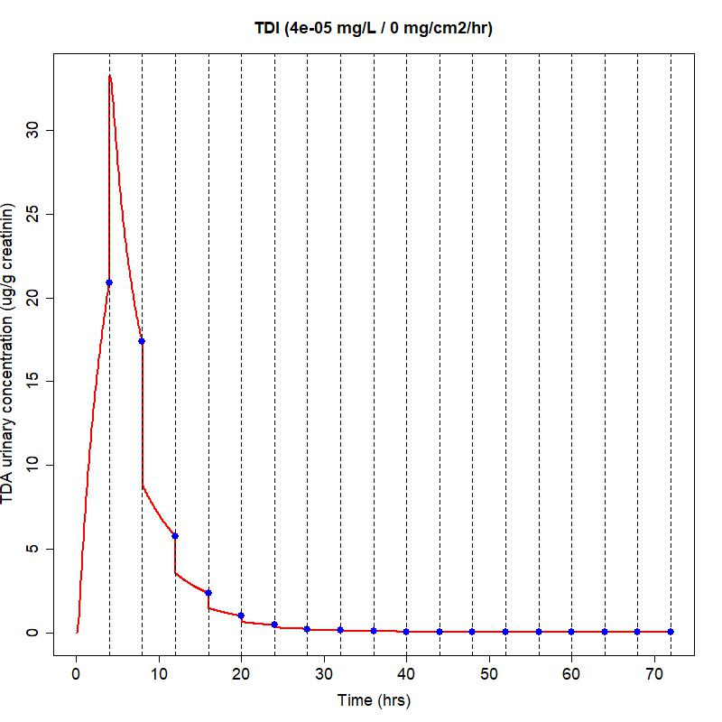
Figure S1. Estimated urinary concentrations of TDA (in μg/g creatinin) after inhalatory exposure to 40 µg/m3 of TDI for 4 hours, with urination every 4 hours. Urination moments are indicated by dotted lines with predicted urinary concentrations indicated by a blue dot.

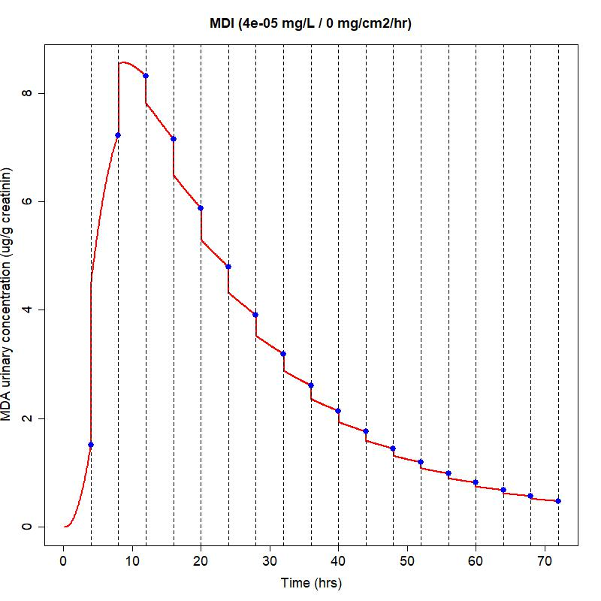
Figure S2. Estimated urinary concentrations of MDA (in μg/g creatinine) after inhalatory exposure to 40 µg/m3 of MDI for 4 hours, with urination every 4 hours. Urination moments are indicated by dotted lines with predicted urinary concentrations indicated by a blue dot.

Appendix F – Dermal exposure to MDI

A  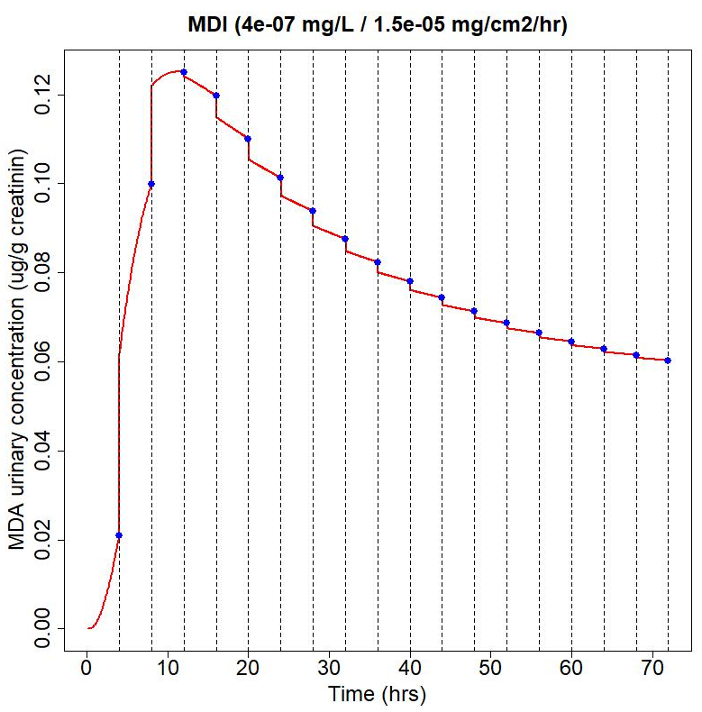 | B  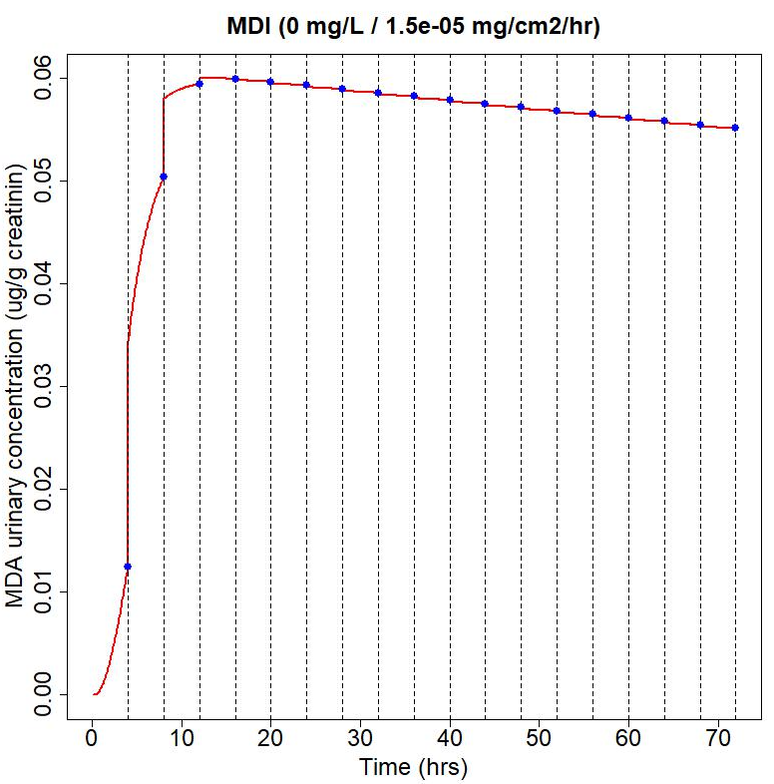
Figure S3: Predicted urinary concentrations of MDA (in μg/g creatinin) after 4 hours of both dermal (0.015 ug MDI/cm2/hour) and inhalatory (0.4 ug MDI/m3) exposure to MDI (A), or after dermal exposure only (B).

Appendix G – Global sensitivity analysis on Monday Morning

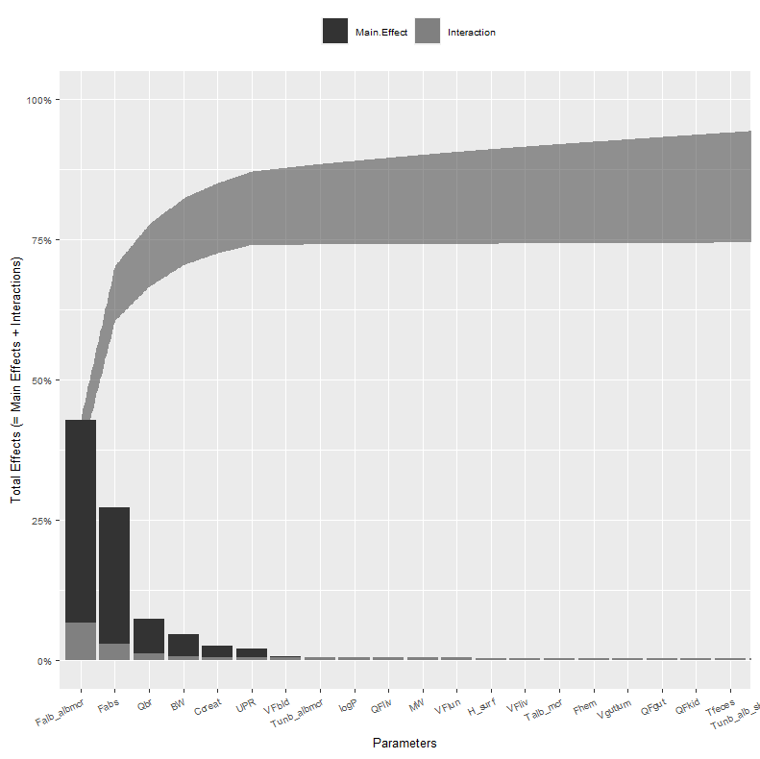
Figure S4. Lowry plot of results from the eFAST sensitivitiy analysis for predicted urinary concentrations of TDA (in µg/gr creatinine) at Monday Morning. Exposure was assumed to occur on 5 days a week, for 8 hours a day (from 9:00 to 17:00), for a period of 8 weeks, with daily urination at 8:00, 13:00, 18:00, and 23:00. The total effect is comprised of the main effects (black bar) and possible interactions with other parameters (grey bar) given as the proportion of variance in the output parameter. The grey ribbon indicates the cumulative proportion of variance explained due to main effects and parameter interactions.

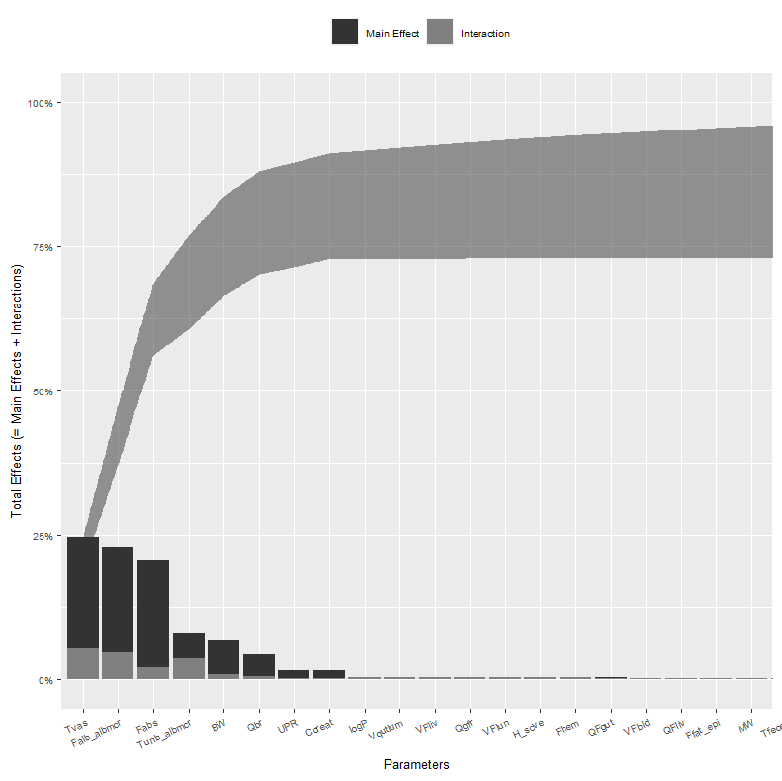
Figure S5. Lowry plot of results from the eFAST sensitivity analysis for predicted urinary concentrations of MDA (in µg/gr creatinine) at Monday morning . Exposure was assumed to occur on 5 days a week, for 8 hours a day (from 9:00 to 17:00), for a period of 8 weeks, with daily urination at 8:00, 13:00, 18:00, and 23:00. The total effect is comprised of the main effects (black bar) and possible interactions with other parameters (grey bar) given as the proportion of variance in the output parameter. The grey ribbon indicates the cumulative proportion of variance explained due to main effects and parameter interactions.

Appendix H – Temporal factors in exposure, analyses for MDI

A  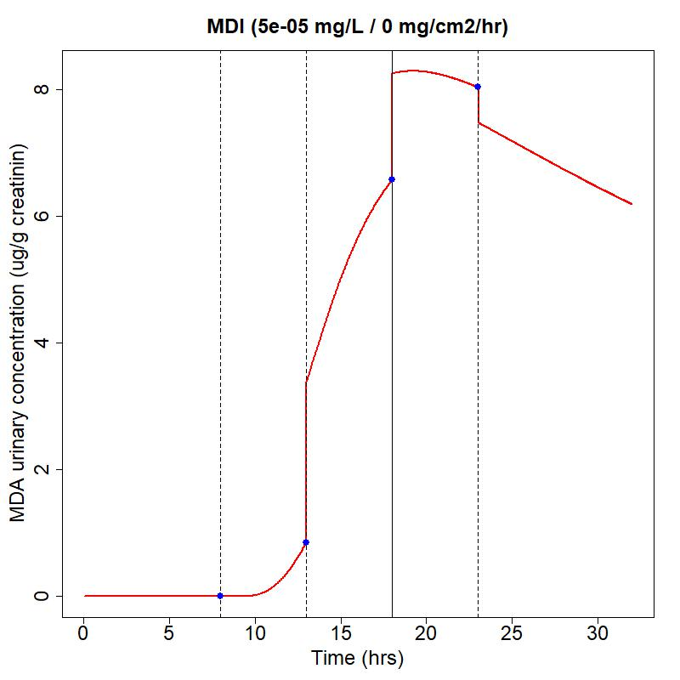 | B  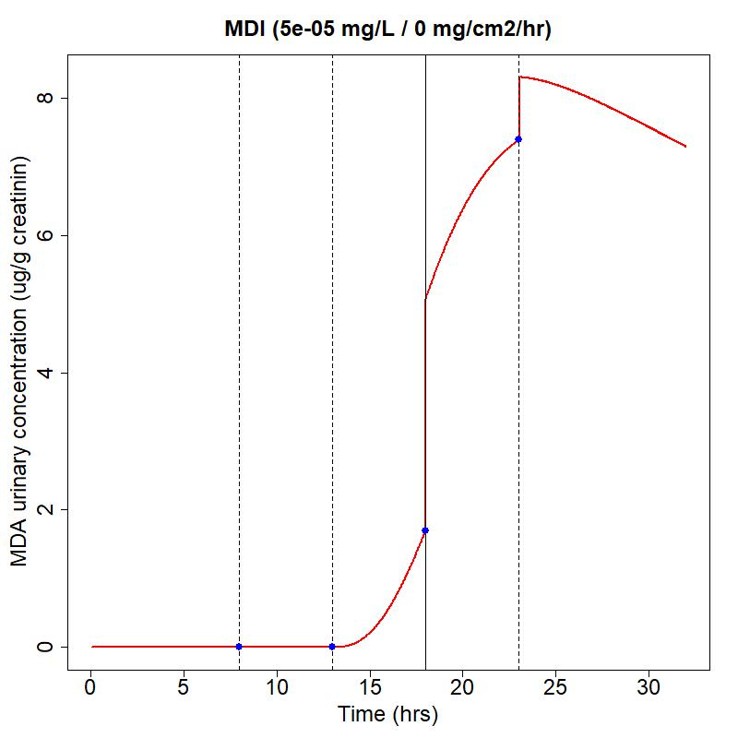
C  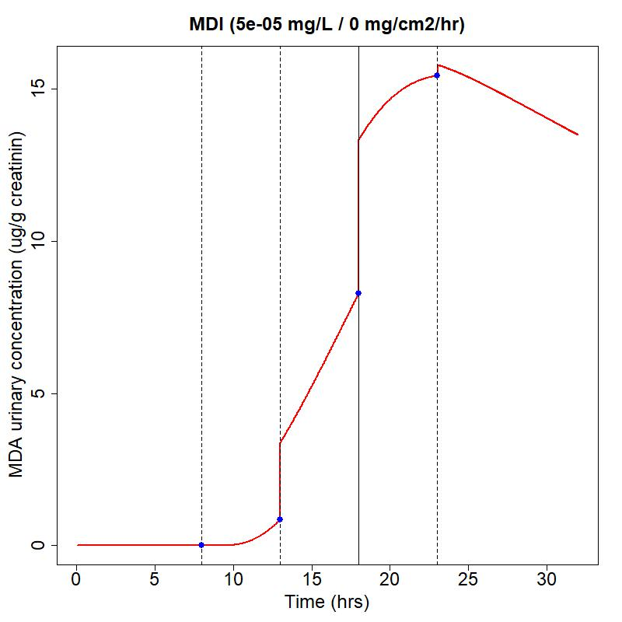 | D  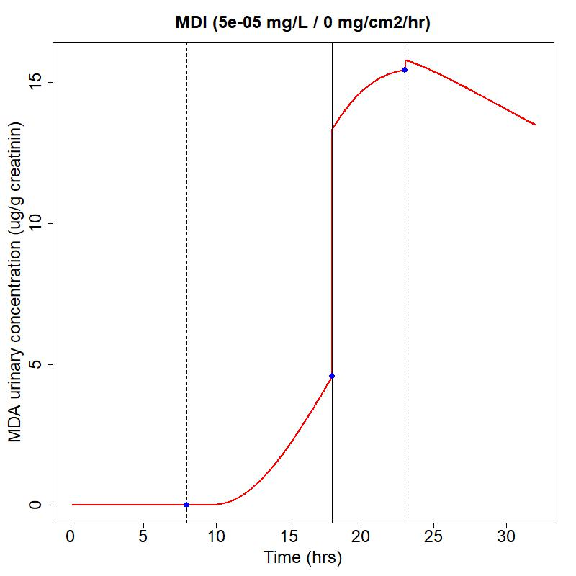
Figure S6. For the early exposure scenario (A), exposure is from 9:00-13:00 and urination at 8:00, 13:00, 18:00, and 23:00. For the late exposure scenario (B), exposure is from 13:00-17:00 and urination at 8:00, 13:00, 18:00, and 23:00. For the frequent urination scenario (C), exposure is from 9:00-17:00 and urination is at 8:00, 13:00, 18:00, and 23:00. For the infrequent urination scenario (D) , exposure is from 9:00-17:00 and urination is at 8:00, 18:00, and 23:00.

References Appendix
Austin, Shaun. 2007. “Biological Monitoring of TDI-Derived Amines in Polyurethane Foam Production.” Occupational Medicine. https://doi.org/10.1093/occmed/kqm085.
Bello, Anila, Yalong Xue, Rebecca Gore, Susan Woskie, and Dhimiter Bello. 2019. “Assessment and Control of Exposures to Polymeric Methylene Diphenyl Diisocyanate (PMDI) in Spray Polyurethane Foam Applicators.” International Journal of Hygiene and Environmental Health 222 (5): 804–15. https://doi.org/10.1016/J.IJHEH.2019.04.014.
Brorson, Torbjorn, Gunnar Skarping, and Carsten Sango. 1991. “Biological Monitoring of Isocyanates and Related Amines.” International Archives of Occupational and Environmental Health. https://doi.org/10.1007/bf00386374.
Budnik, Lygia T., Dennis Nowak, Rolf Merget, Catherine Lemiere, and Xaver Baur. 2011. “Elimination Kinetics of Diisocyanates after Specific Inhalative Challenges in Humans: Mass Spectrometry Analysis, as a Basis for Biomonitoring Strategies.” Journal of Occupational Medicine and Toxicology. https://doi.org/10.1186/1745-6673-6-9.
Geens, Tom, Sandra Dugardin, Ann Schockaert, Geert De Cooman, and Marc Van Sprundel. 2012. “Air Exposure Assessment of TDI and Biological Monitoring of TDA in Urine in Workers in Polyurethane Foam Industry.” Occupational and Environmental Medicine 69 (2): 93–98. https://doi.org/10.1136/OEM.2011.064840.
Gledhill, A., A. Wake, P. Hext, E. Leibold, and R. Shiotsuka. 2008. “Absorption, Distribution, Metabolism and Excretion of an Inhalation Dose of [14C] 4,4’-Methylenediphenyl Diisocyanate in the Male Rat.” Http://Dx.Doi.Org/10.1080/00498250500057591 35 (3): 273–92. https://doi.org/10.1080/00498250500057591.
Henriks-Eckerman, Maj Len, Erja A. Mäkelä, Juha Laitinen, Katriina Ylinen, Katri Suuronen, Aki Vuokko, and Riitta Sauni. 2015. “Role of Dermal Exposure in Systemic Intake of Methylenediphenyl Diisocyanate (MDI) among Construction and Boat Building Workers.” Toxicology Letters 232 (3): 595–600. https://doi.org/10.1016/J.TOXLET.2014.12.012.
Hettick, J, and P.D Siegel. 2011. “Determination of the Toluene Diisocyanate Binding Sites on Human Serum Albumin by Tandem Mass Spectrometry.” Analytical Biochemistry 414.2: 232–38.
Kääriä, K, A Hirvonen, H Norppa, P Piirilä, H Vainio, and C Rosenberg. 2001. “Exposure to 2,4- and 2,6-Toluene Diisocyanate (TDI) during Production of Flexible Foam: Determination of Airborne TDI and Urinary 2,4- and 2,6-Toluenediamine (TDA).” Analyst 126 (7): 1.
Maître, A., M. Berode, A. Perdrix, S. Romazini, and H. Savolainen. 1993. “Biological Monitoring of Occupational Exposure to Toluene Diisocyanate.” International Archives of Occupational and Environmental Health 1993 65:2 65 (2): 97–100. https://doi.org/10.1007/BF00405726.
Sennbro, C. J., C. H. Lindh, C. Mattsson, B. A.G. Jönsson, and H. Tinnerberg. 2006. “Biological Monitoring of Exposure to 1,5-Naphthalene Diisocyanate and 4,4′-Methylenediphenyl Diisocyanate.” International Archives of Occupational and Environmental Health 79 (8): 647–53. https://doi.org/10.1007/S00420-006-0096-5/FIGURES/2.
Sennbro, Carl J., Christian H. Lindh, Anders Östin, Hans Welinder, Bo A.G. Jönsson, and Håkan Tinnerberg. 2004. “A Survey of Airborne Isocyanate Exposure in 13 Swedish Polyurethane Industries.” The Annals of Occupational Hygiene 48 (5): 405–14. https://doi.org/10.1093/ANNHYG/MEH034.
Skarping, Gunnar, Torhjörn Brorson, and Carsten Sangö. 1991. “Biological Monitoring of Isocyanates and Related Amines.” International Archives of Occupational and Environmental Health 1991 63:2 63 (2): 83–88. https://doi.org/10.1007/BF00379069.
Swierczyńska-Machura, Dominika, Sławomir Brzeźnicki, Ewa Nowakowska-Swirta, and Jolanta Walusiak-Skorupa. 2015. “Occupational Exposure to Diisocyanates in Polyurethane Foam Factory Workers Good Practice in Occupational Health Services: Recommendations for Prophylactic Examinations in Patients with Diabetes Mellitus View Project Prevention of Hypertension and Diabetes in Occupational Prophylactic Care View Project.” Article in International Journal of Occupational Medicine and Environmental Health. https://doi.org/10.13075/ijomeh.1896.00284.
Timchalk, C., F. A. Smith, and M. J. Bartels. 1994. “Route-Dependent Comparative Metabolism of [14C]Toluene 2,4-Diisocyanate and [14C]Toluene 2,4-Diamine in Fischer 344 Rats.” Toxicology and Applied Pharmacology. https://doi.org/10.1006/taap.1994.1022.
Tinnerberg, Håkan, Karin Broberg, Christian H. Lindh, and Bo A.G. Jönsson. 2014. “Biomarkers of Exposure in Monday Morning Urine Samples as a Long-Term Measure of Exposure to Aromatic Diisocyanates.” International Archives of Occupational and Environmental Health 87 (4): 365–72. https://doi.org/10.1007/S00420-013-0872-Y/FIGURES/3.

Urinary waarden zijn omgezet naar ug/gr creatinine door middel van deze gegevens: creatinine value: 12 mmol/L. MW creatinine: 113.12 g/mol. MW TDA: 122.17 g/mol.
Autheurs also make a correction from ug/l to ug/gr creatinine. They calculate 6.9 (instead of 7.1), I think this is because they used a value of 12.5 mmol/L. We use 12 mmol/L throughout so also here we use this value.

